# EC Example Library

**Prompt Errors**

Bad Prompt: The prompt is unanswerable as stated

**Incorrect / Missed Model Actions**

1. UI Grounding Errors
2. Incorrect / Missed Use of UI Element
3. Missed Opportunity to Extract Info
4. Early Stopping (Premature Task Satisfaction)
5. Early Stopping (Insufficient Persistence)
6. Looping Over Failed Actions
7. Unreasonable Step
8. Dynamic Events
9. UI Misunderstanding

**Incorrect / Missed Model Thoughts**

1. Prompt Misunderstanding
2. Information Hallucination (Text)
3. Information Hallucination (Visual)
4. UI Hallucination
5. Time Misunderstanding
6. Thought Verification Error

**Model Output Error**

1. Summarization Failure
2. Dissatisfactory Output

**Infrastructure Errors**

1. Run Crashes
2. Bot / Captcha / Proxy issues
3. Auth/login issues

**Tool Errors**

1. Tool returns incorrect/outdated info or broken/generic/wrong links

# 

# 

# **Prompt Errors**

## Bad Prompt: The prompt is unanswerable as stated

Examples:

* The prompt does not make logical sense
  + Should be “***returning*** between January 1-7 2026”  
    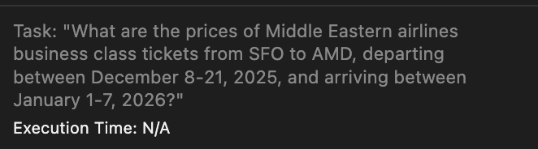
* The prompt is so ambiguous that the status of the task cannot be determined.
  + In this case, there are multiple unclear points. Which highway? Is the interest in exactly 15 minutes, or more or less than 15 minutes? This makes it difficult to judge if the model did the right thing
  + 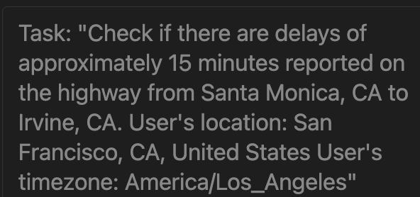
* The specified date or event is in the past, so it cannot be checked in the present
  + Execution in June, but checking for a reservation time in May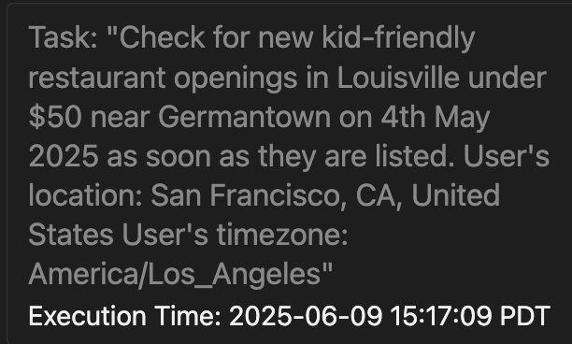
  + Execution after a specific event has passed, like the “Memorial Day Sale” or “Prime Day Sale,” so the task is unverifiable afterward



**Incorrect / Missed Model Actions**

## UI Grounding Errors

When the model’s intended click action does not match the action actually taken.

Examples:

The model intends to click on a particular element, but clicks somewhere else

* 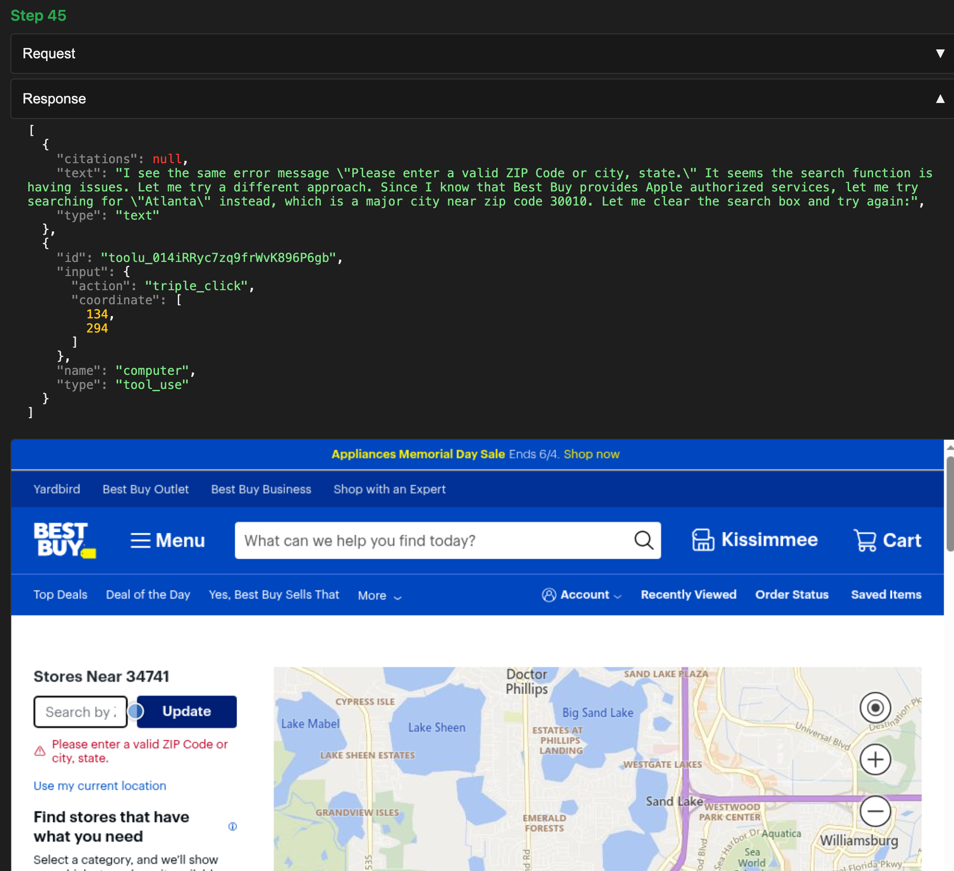

### **When to Mark UI Grounding Error:**

* When a **click action** is involved (it is necessary for marking a UI Grounding Error).
* When the **intended click action** does not **match the action actually performed**.

### **When *Not* to Mark UI Grounding Error**

* When the model **intends to click** but instead performs a **different action**, such as ‘*scroll’* or ‘*read_texts_and_links*.’
* When the model **misinterprets the functionality** of a UI element. *(This should be marked as a UI Misunderstanding instead.)*
* When the model **hallucinates the presence** of a non-existent UI element. *(This should be marked as a UI Hallucination instead.)*

## Incorrect / Missed Use of UI Element

When the model has incorrectly used or missed the use of a UI element (like a filter, search)

Examples:

* Not finding and using the filters that are available
  + Task asked for “newest” but the agent did not sort by that; kept “Best Match”
  + 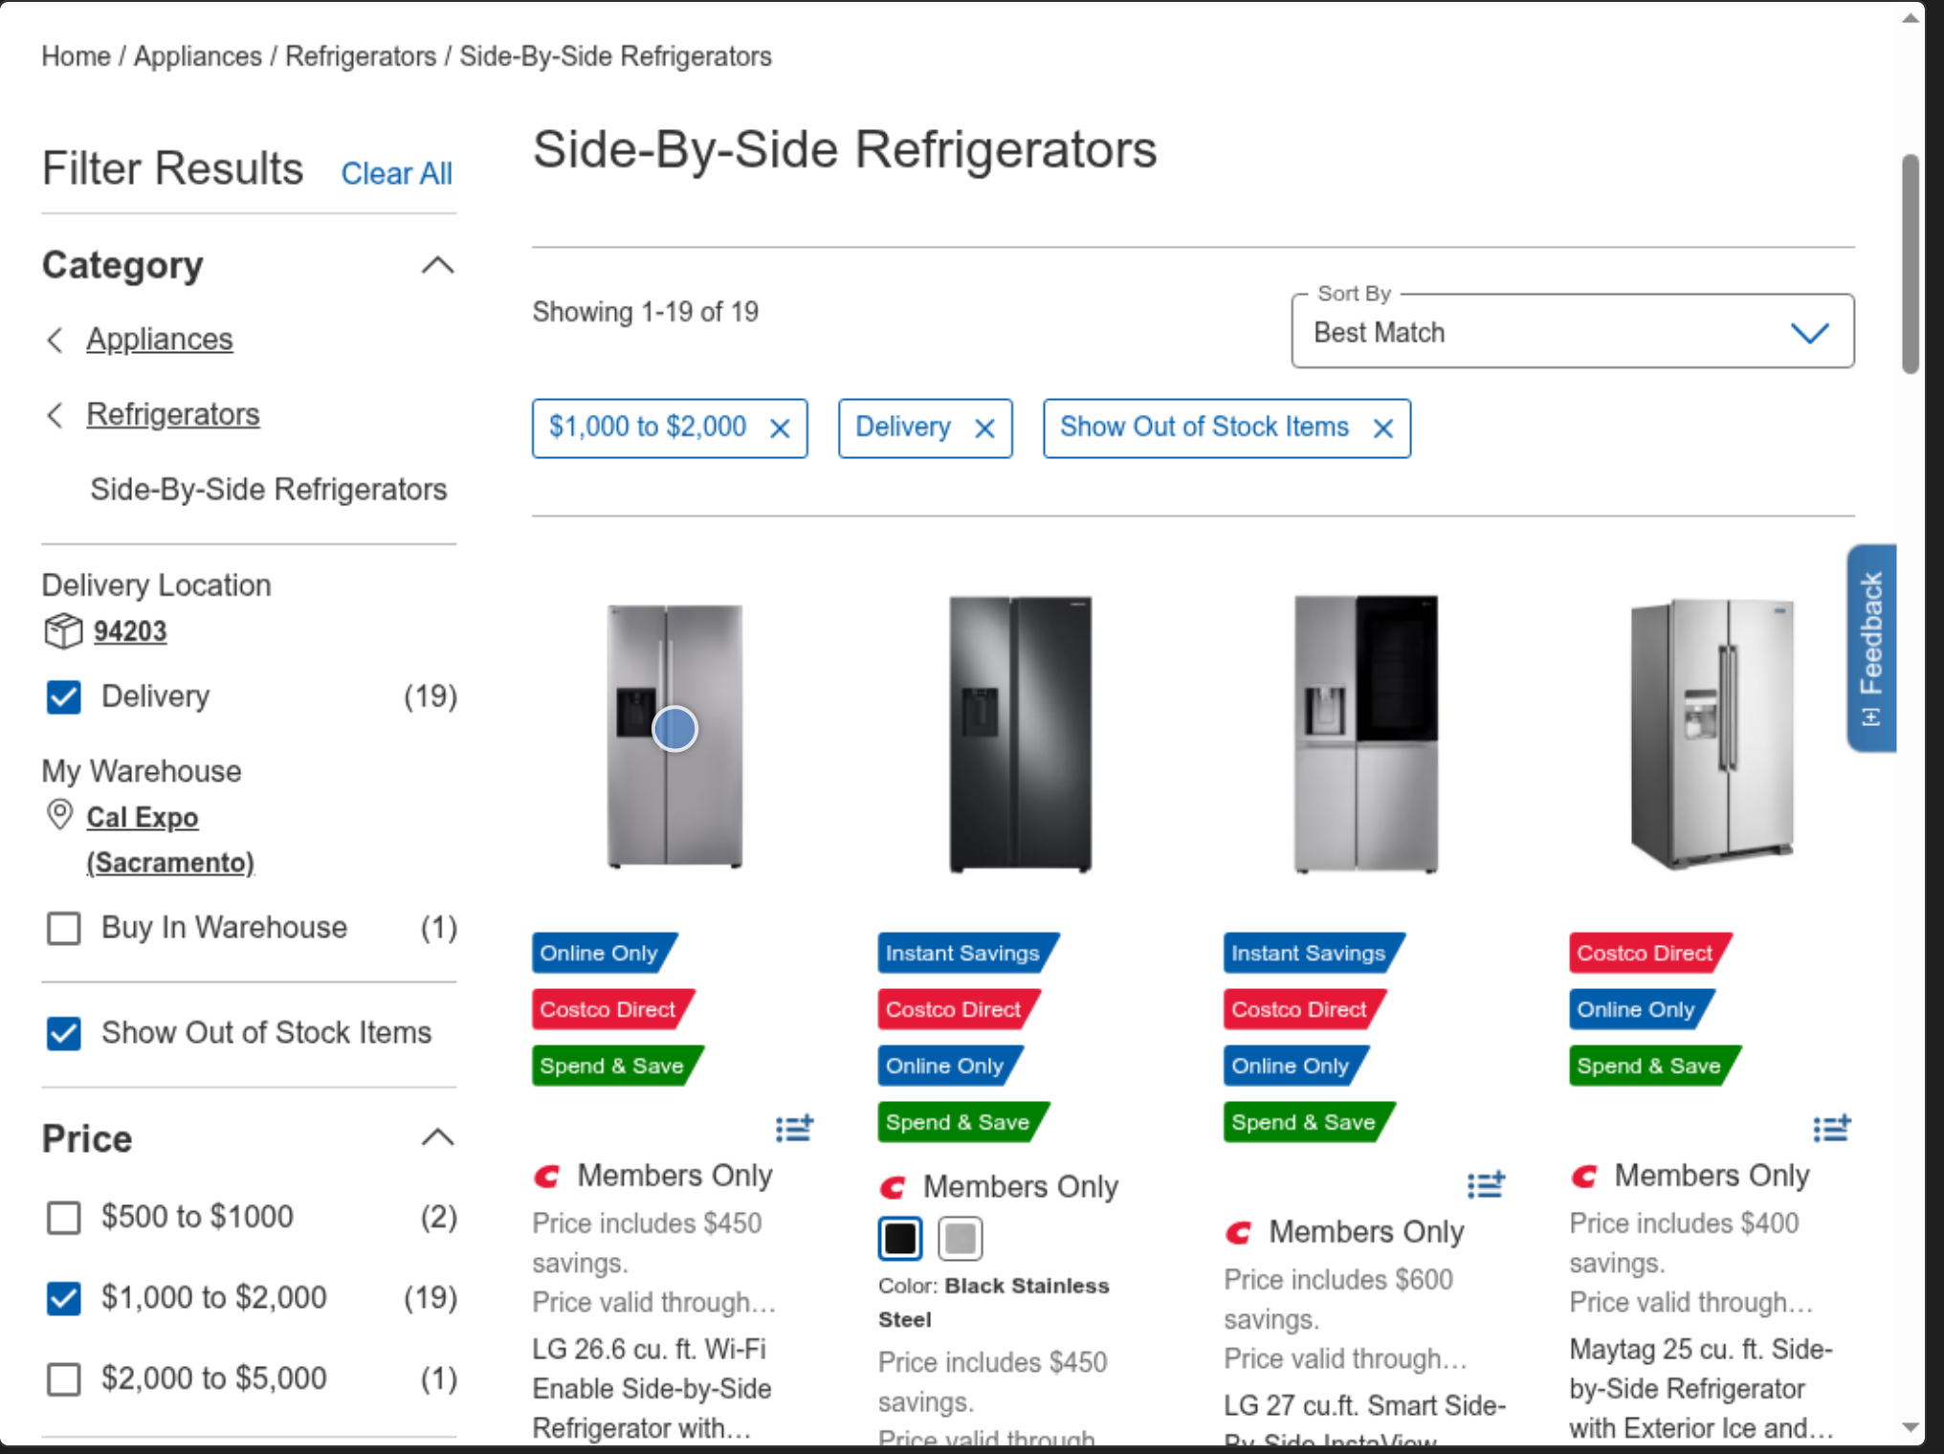
* Scrolling on a website to find an article instead of using search when it is available
  + 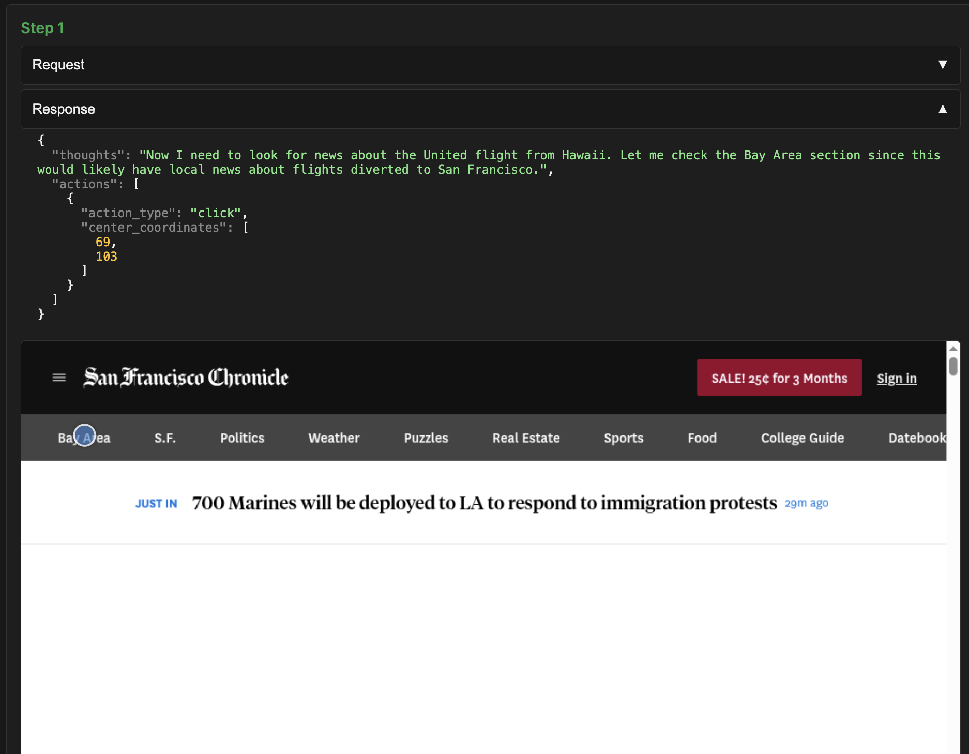

## Missed Opportunity to Extract Info

Model misses the opportunity to extract relevant information for the task by calling the “**read_texts_and_links tool**”, which leads to missing the key information in the output

When it is used correctly, you will see this as part of the model response.

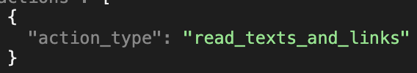

Examples:

* Model navigated to the right information, but instead of calling the “read_texts_and_links” tool to extract the URL/information for the final output it kept scrolling
  + 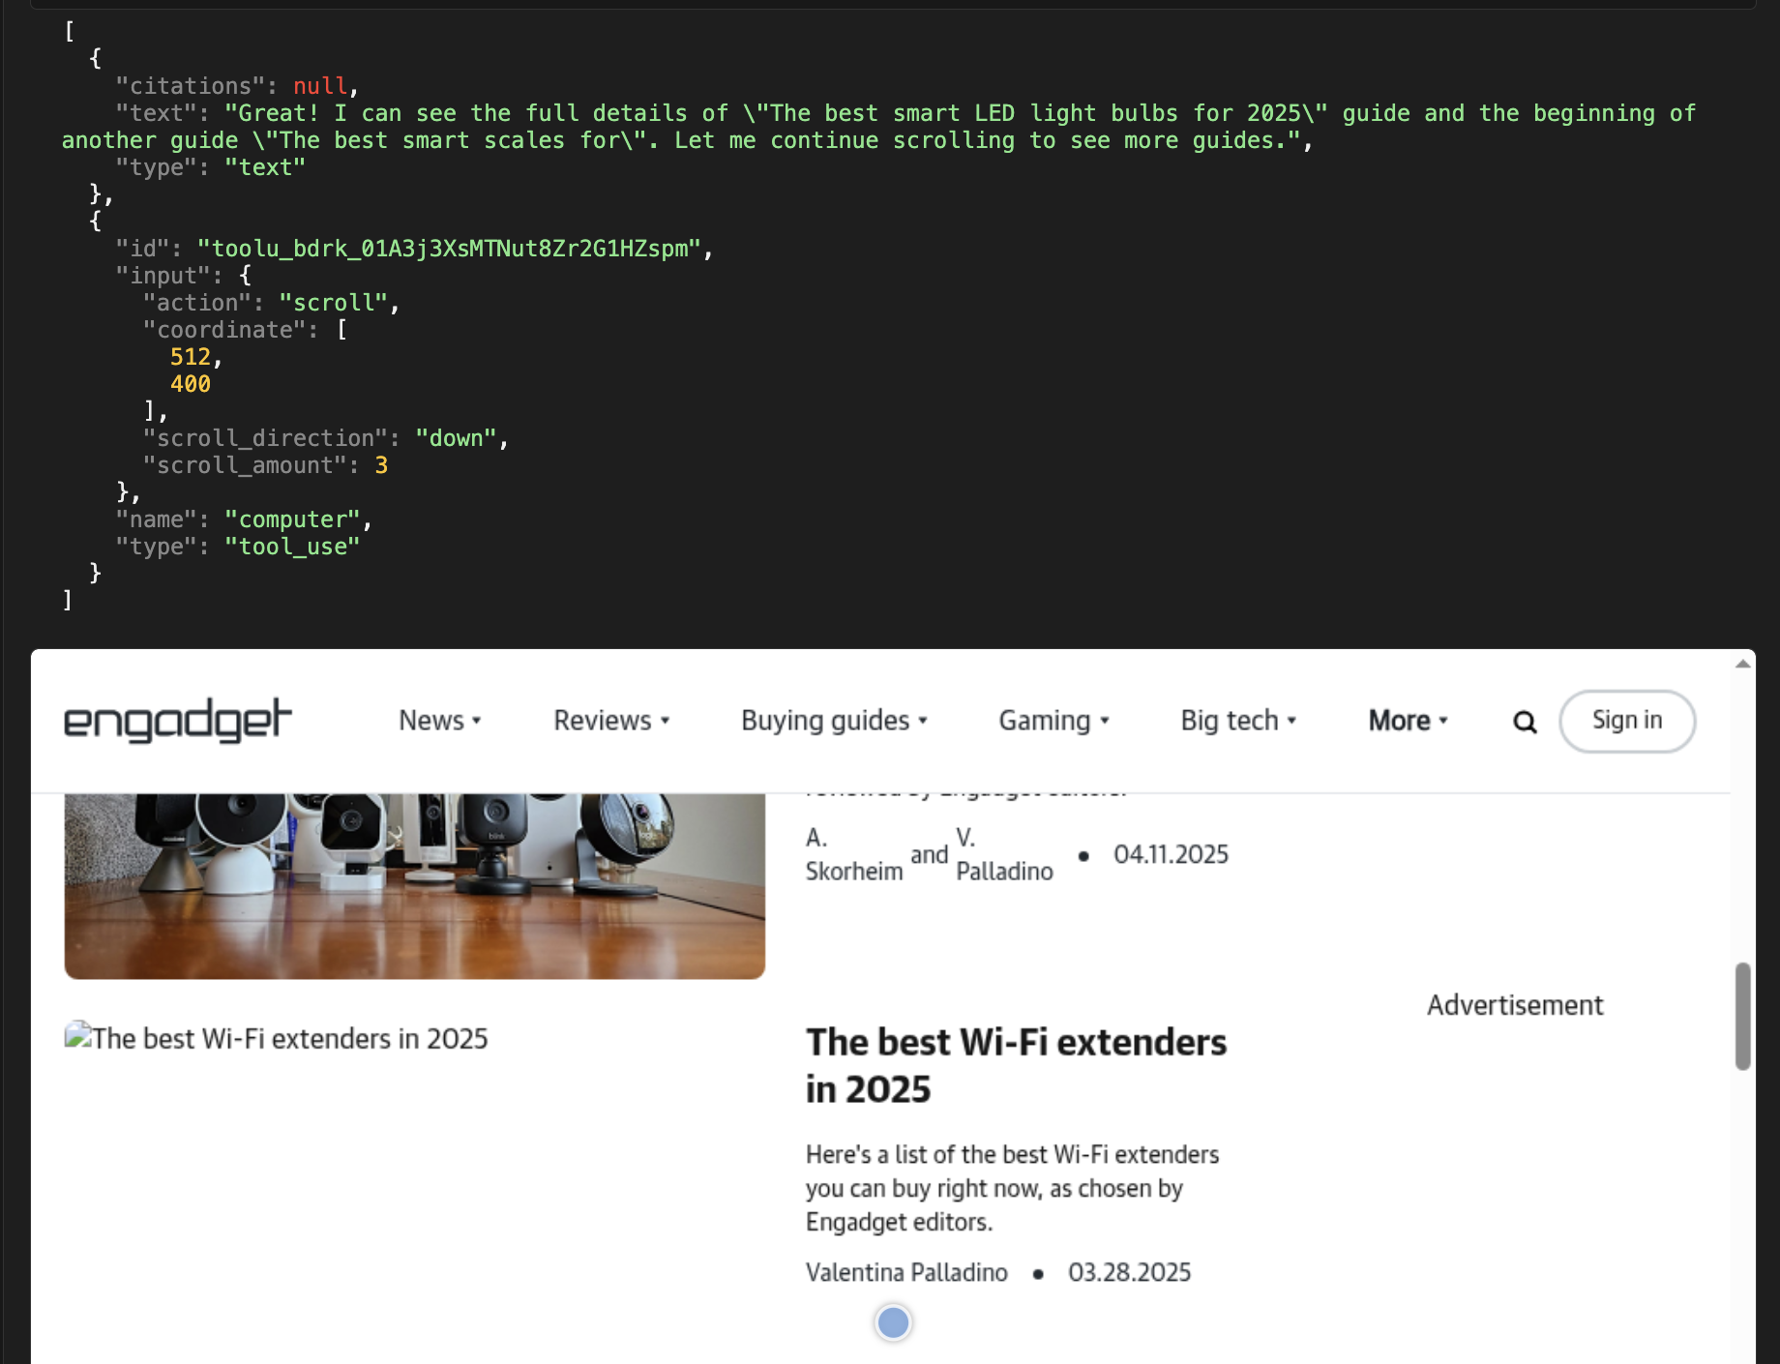
* The model found the right tweet that addresses the task but misses the opportunity to extract the screenshot of the task as task specifies and instead keeps scrolling
  + 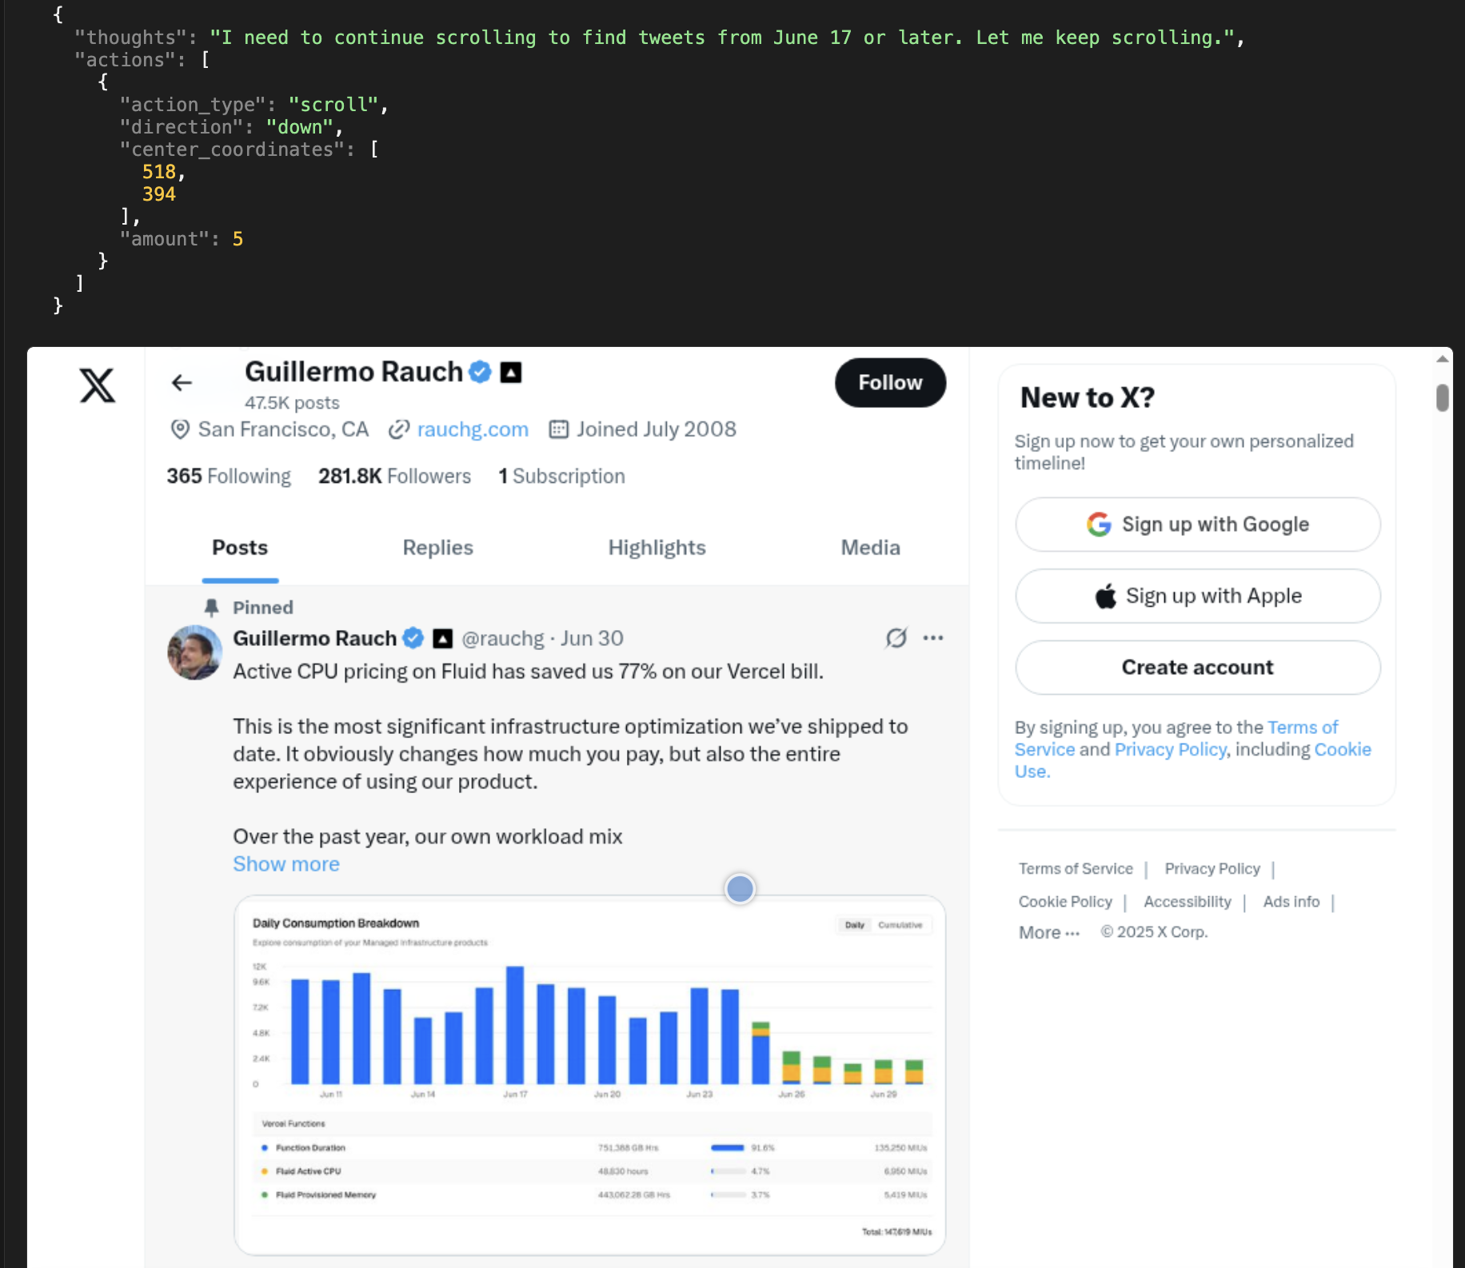

## Early Stopping (Premature Task Satisfaction)

The model stops too early, assuming the task is done even when the task is not complete (before step 75).

Examples:

* Misses opportunity to get more info, when the task asks for it (e.g. “earliest example”). In this case it missed pressing “Load more news”
  + 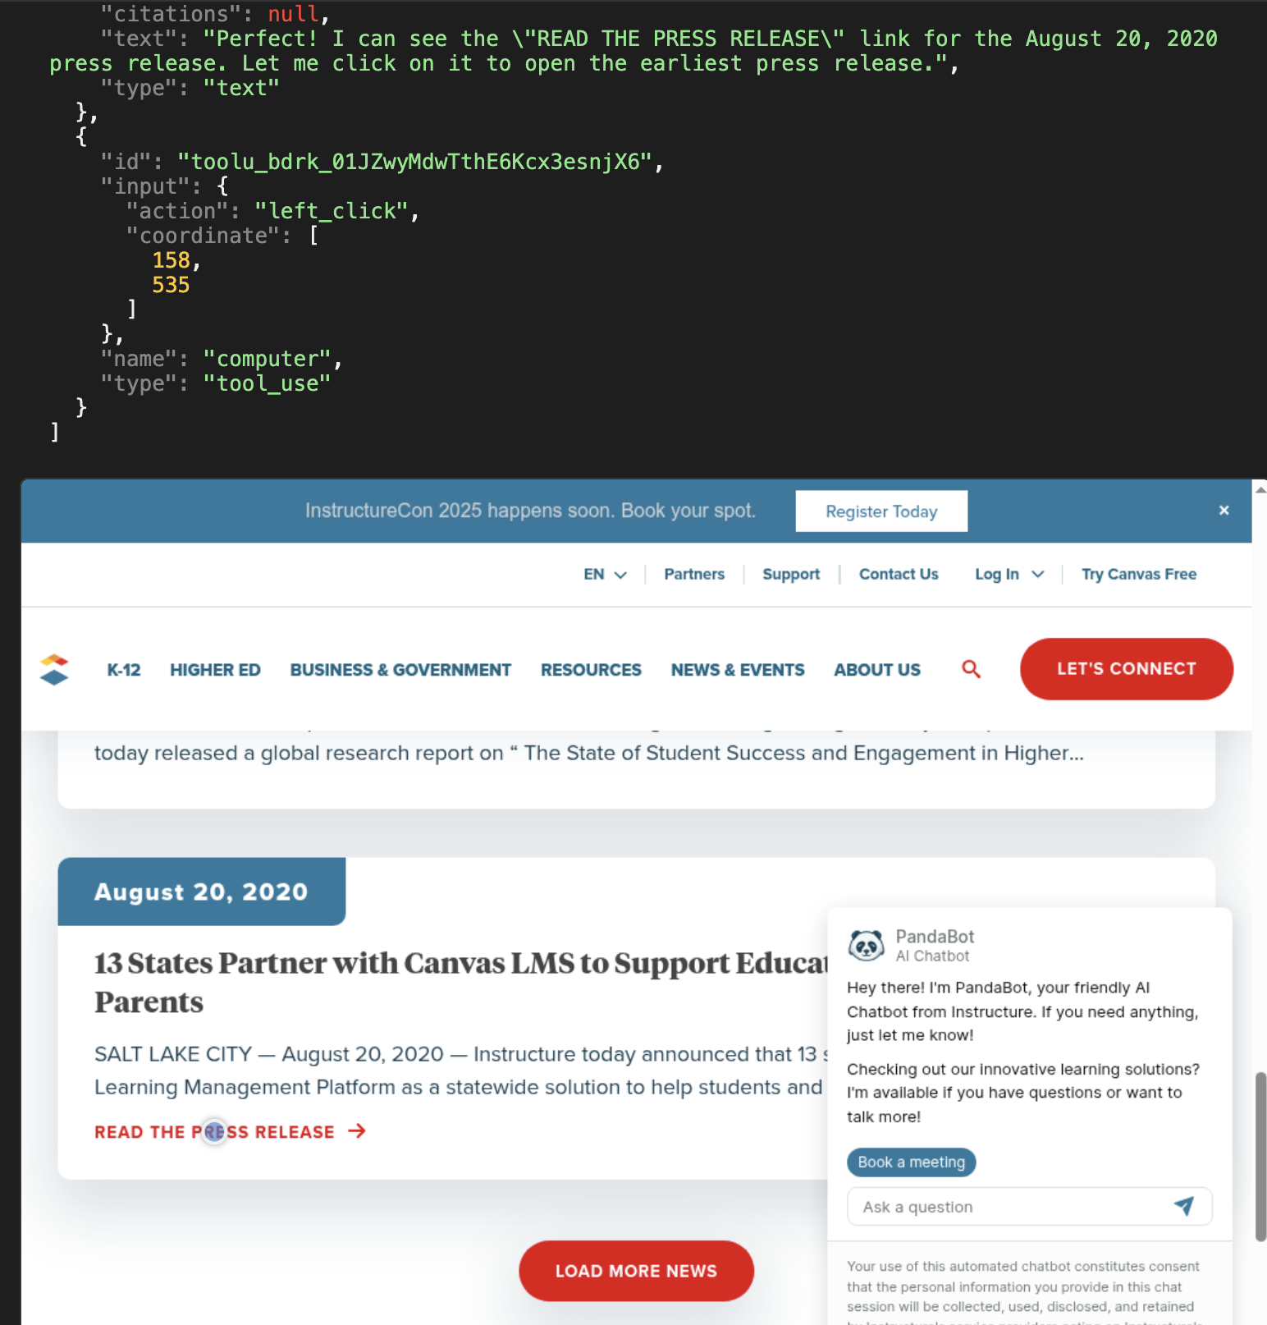
* In [this example](https://dashboard.yutori.ai/logs/experiment_r2_hq_rt__0701_pr_prompts__0701/27/), the task asks for “Google Trends for 'AI agents' …. Note … any regional information available.” At the end, we see this screenshot:
  + 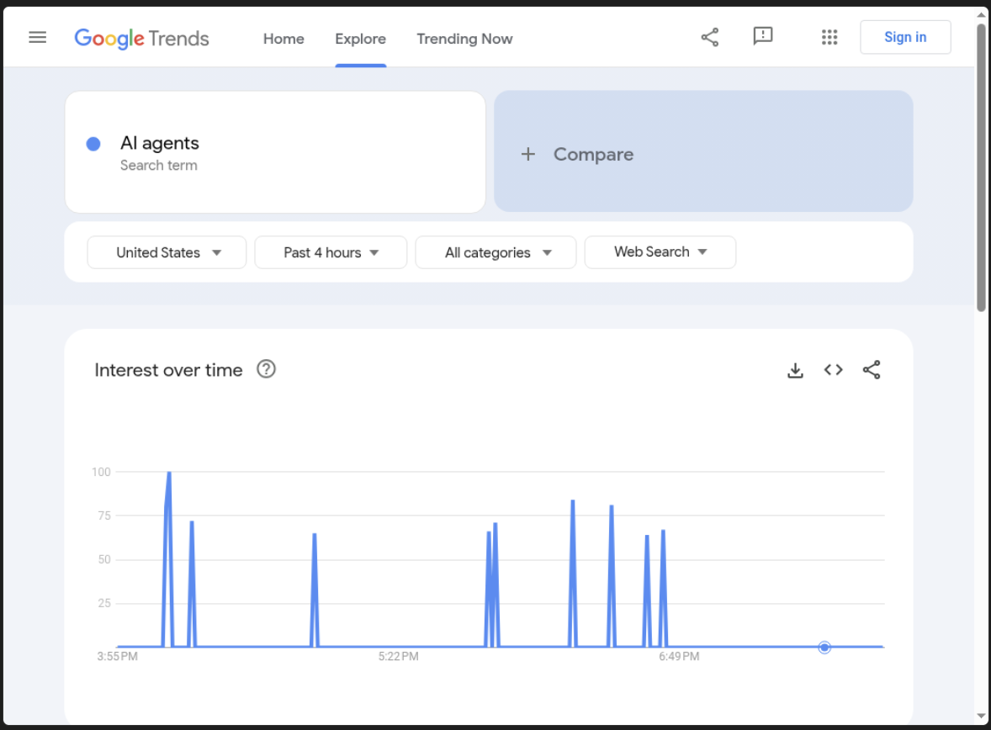
  + However, the model should’ve scrolled down, where there is region information (which is missing from the model output)
  + 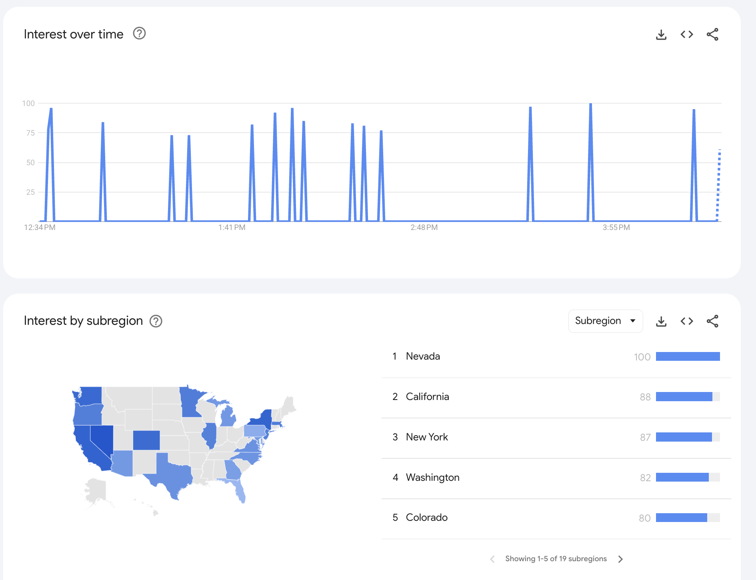

# 

## Early Stopping (Insufficient Persistence)

* The model stops too early, acknowledging tasks are not done, and gives up too easily.
* The model is aware of task requirements but gives up, initiating “stop” too early (before step 75). Choose this one if the model acknowledges / explicitly states that it knows it failed to complete the task.

Examples:

* When a task is possible to complete, but the agent gives up too early
  + 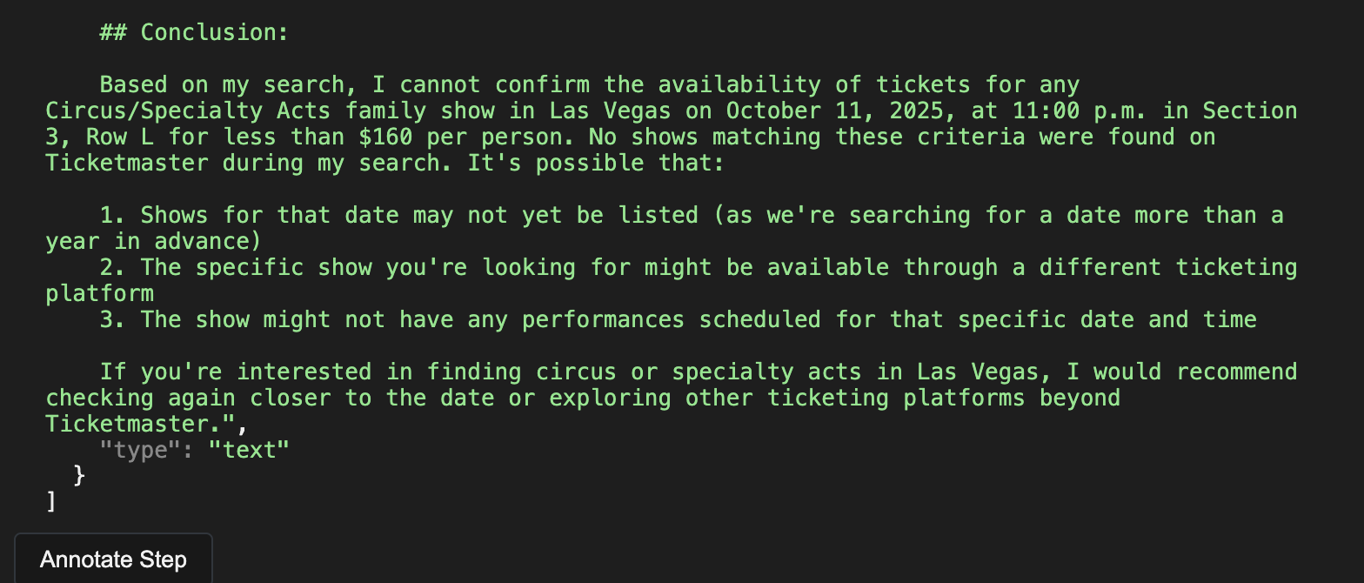

## 

## 

## 

## Looping Over Failed Actions

Model loops over a failed action, repeating the same error/mistake. If the same error has occurred **3+ times**, including the initial failure.

Examples:

* Continuous scrolling through language options though it missed the correct one (Chinese) earlier on
  + 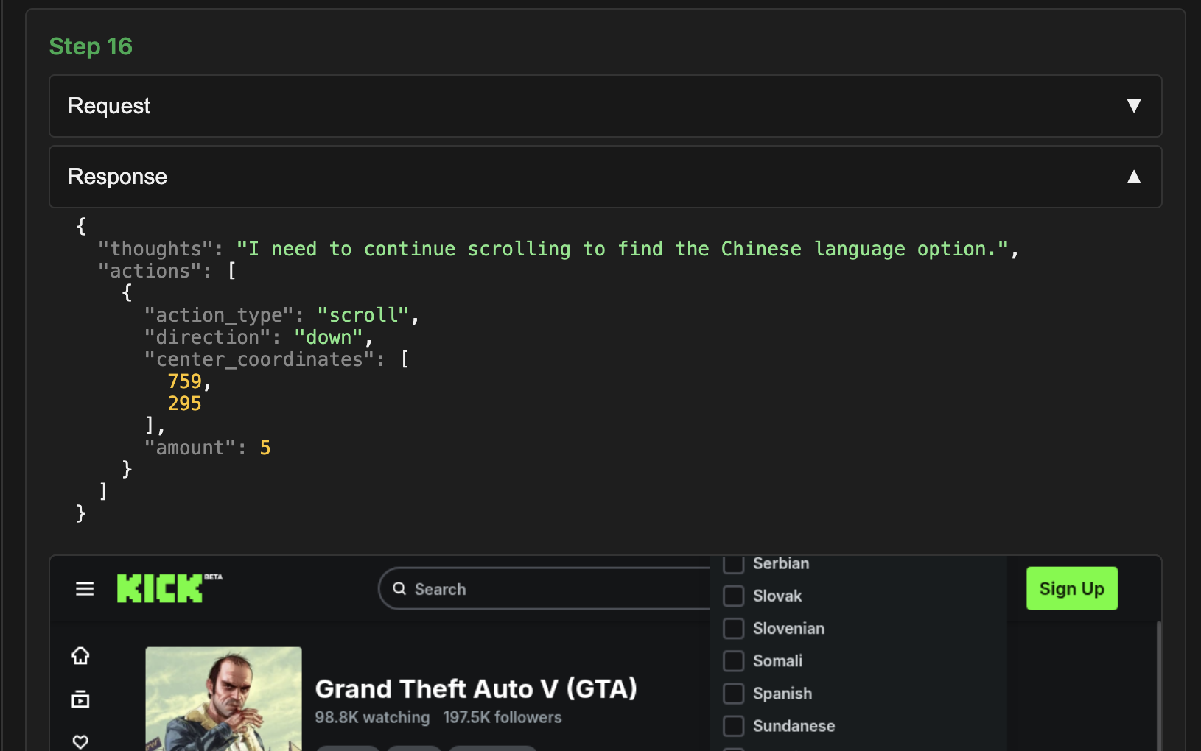
  + 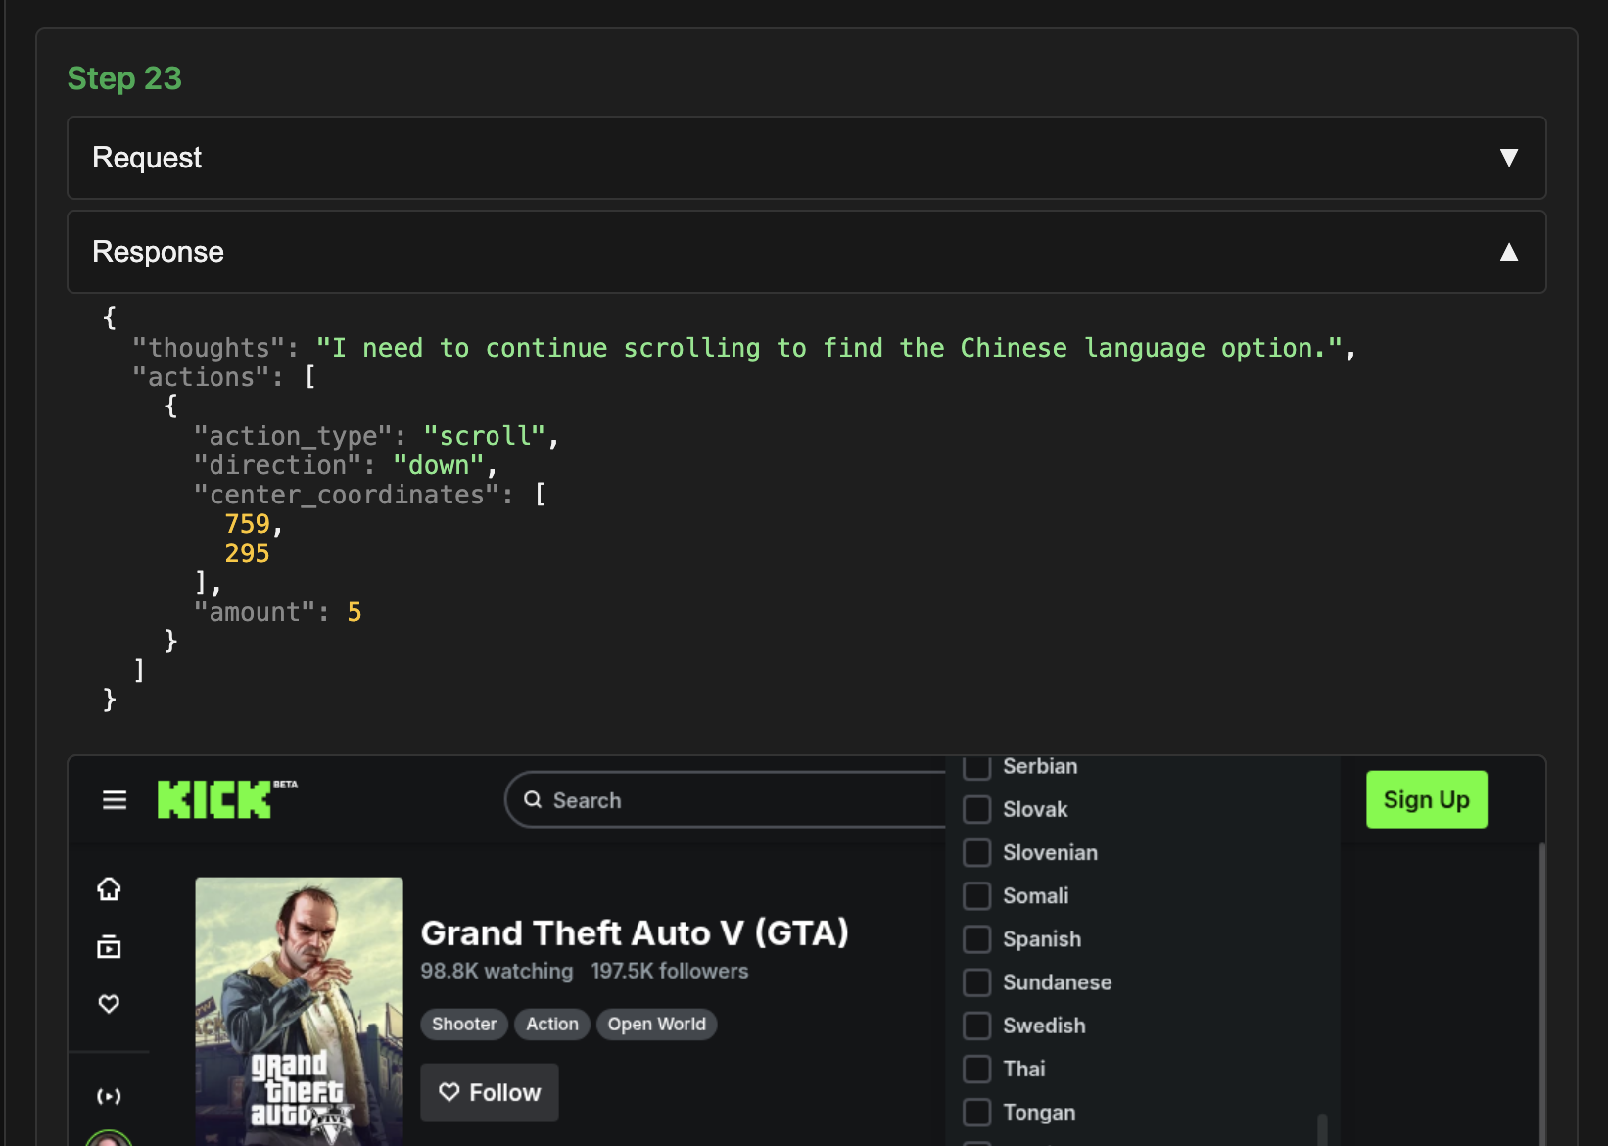
* Trying to click on 29 Aug over and over but never fixing the issue that it is not currently in view
  + 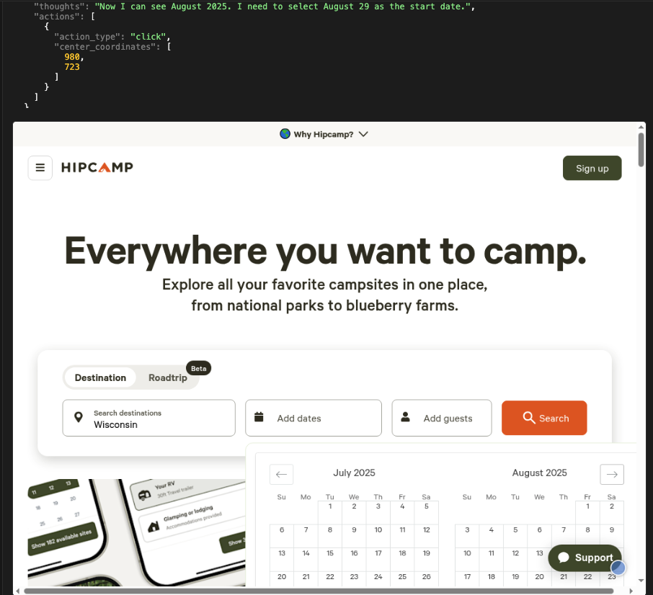

## Unreasonable Step (excluding loops)

When the model does not have the intent to complete the task and takes unreasonable steps that don’t help progress the task.

Examples:

* Task asks for listings posted on June 24, 2025 but the model decides to search for that date under the “rent period” filter which has nothing to do with posting date
  + 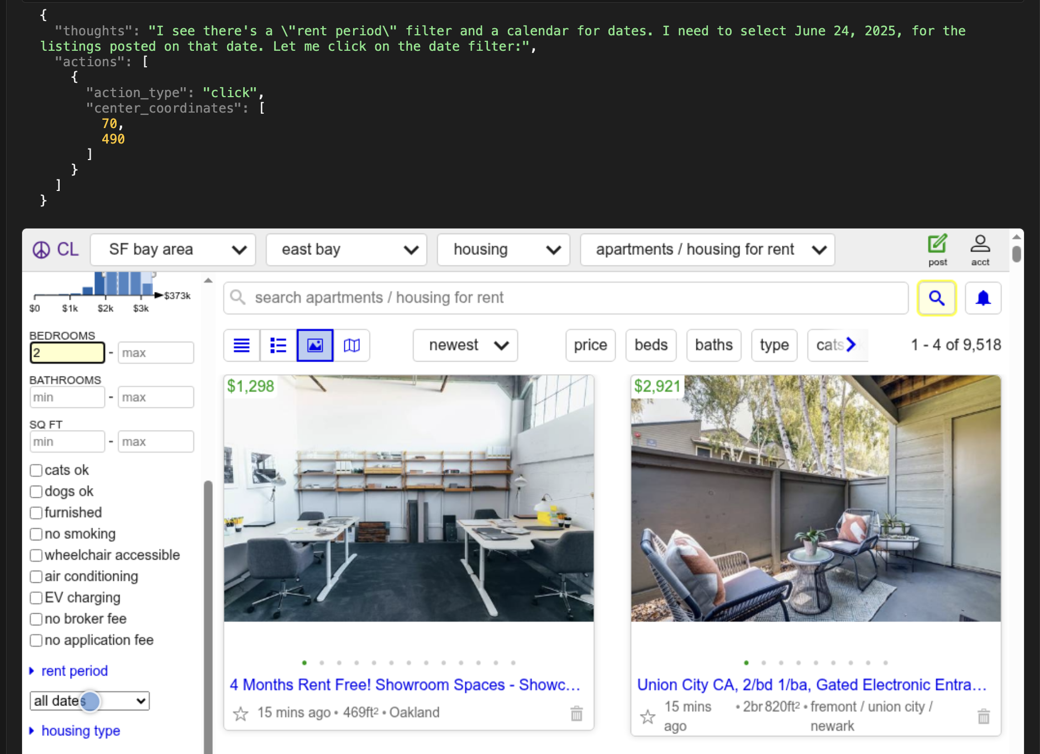

## When to mark unreasonable steps:

## When the model takes an action that **does not contribute to task progress**.

## When the model **goes off-trajectory** and performs an action **irrelevant to the task**.

## When the model **forgets the core intent** of the task and performs actions **unrelated to the main objective**.

## When to mark unreasonable steps:

* When the model is trying to explore the results by navigating to different pages, but doesn’t forget the core intent of the task and still intends to complete it.

## 

## Dynamic Events

When pop-ups or other dynamic UI elements obstruct model actions and the model fails to address them. Note: if the pop up does not interfere with the performance, do not mark.

Examples:

* Did not respond to cookie settings requests (eg “Accept all cookies”)
* Did not respond to ads popups or other pop ups that interfere with work
  + 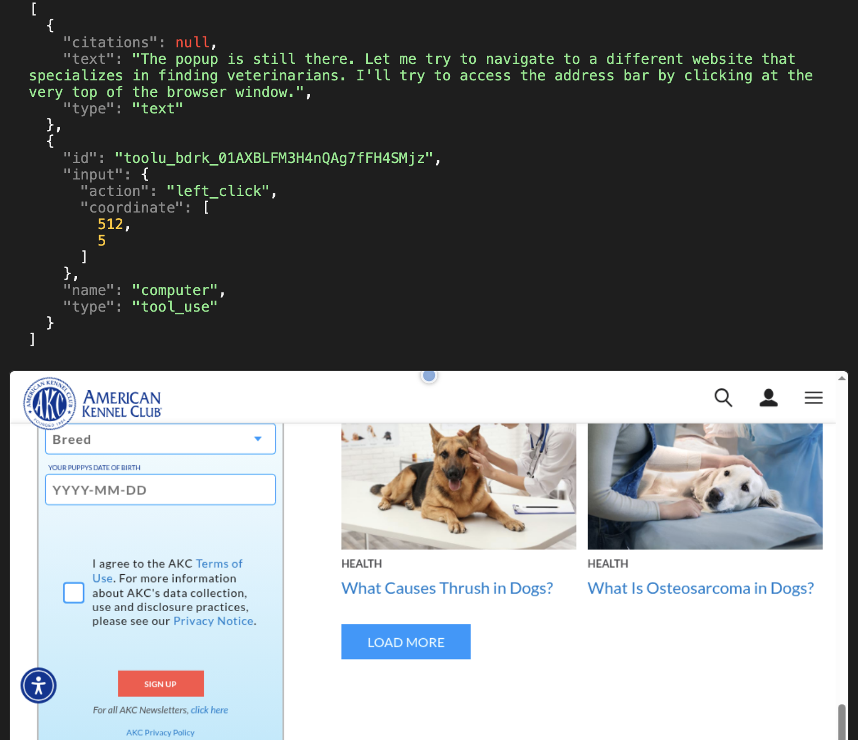
* Failing to handle pop up interferes with the action it intends to take
  + 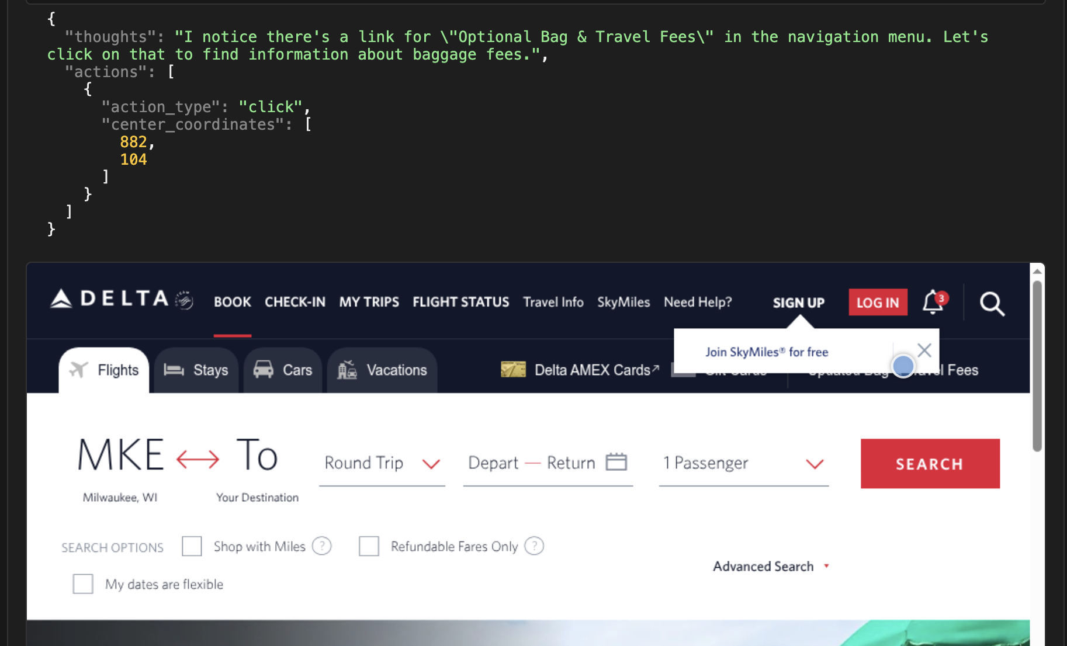

## UI Misunderstanding

Misinterprets the functionality of the UI element.

Examples:

* Tries to click on the greyed-out button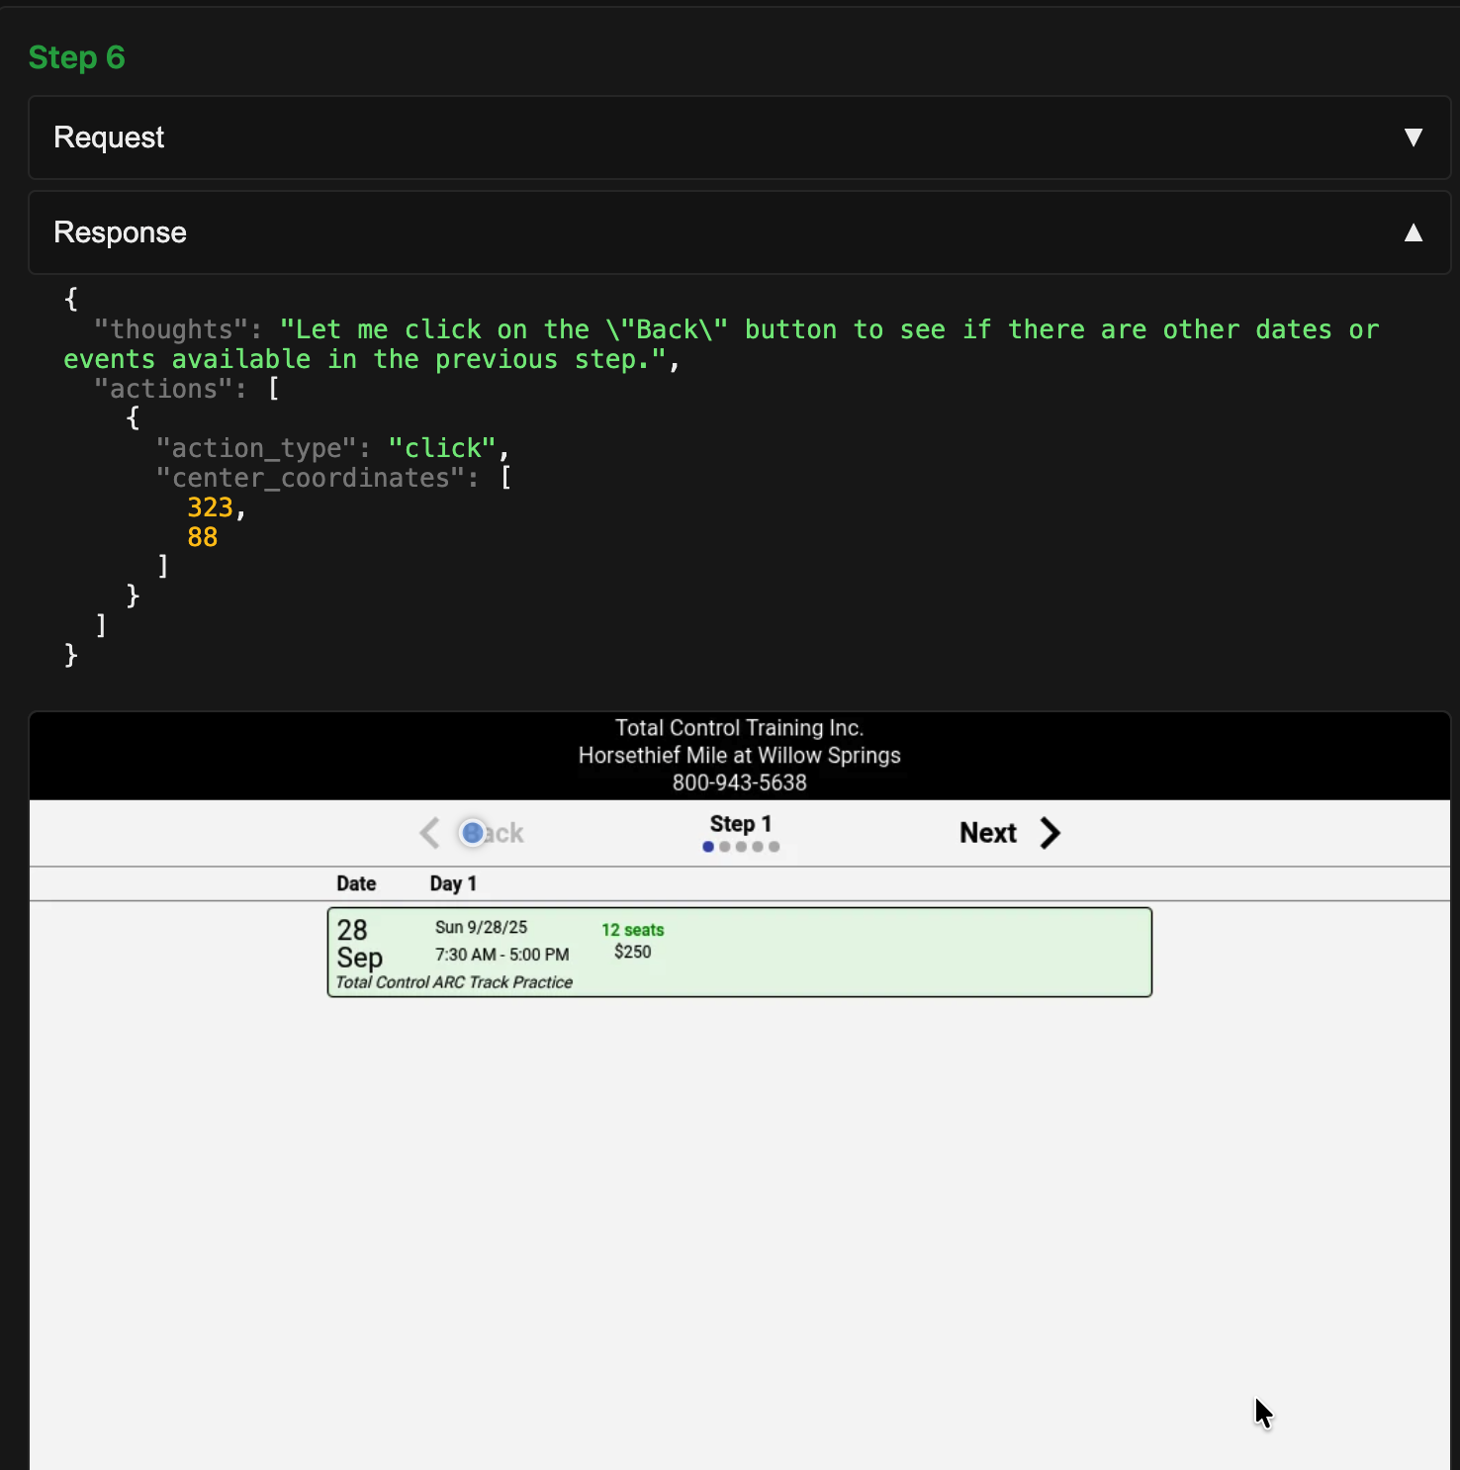

**Incorrect / Missed Model Actions**

## 

## Prompt Misunderstanding

## Misunderstands the prompt or neglects the requirements before beginning the task

The model’s reasoning indicates that it interprets a prompt incorrectly and proceeds to execute with the incorrect intent.

Examples:

* The model decides to create a quiz instead of completing a quiz
  + 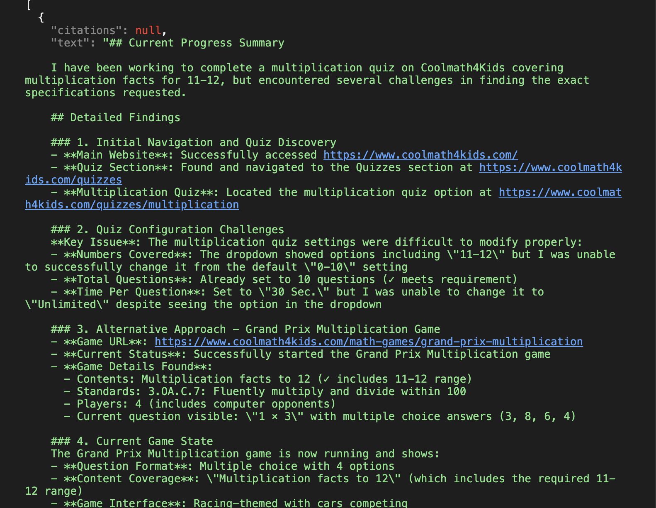

## Information Hallucination (text)

When the model hallucinates the information while summarising or making an inference

Example:

The model incorrectly stated that the Brockton area is part of Boston, whereas it is actually about 20 miles away.

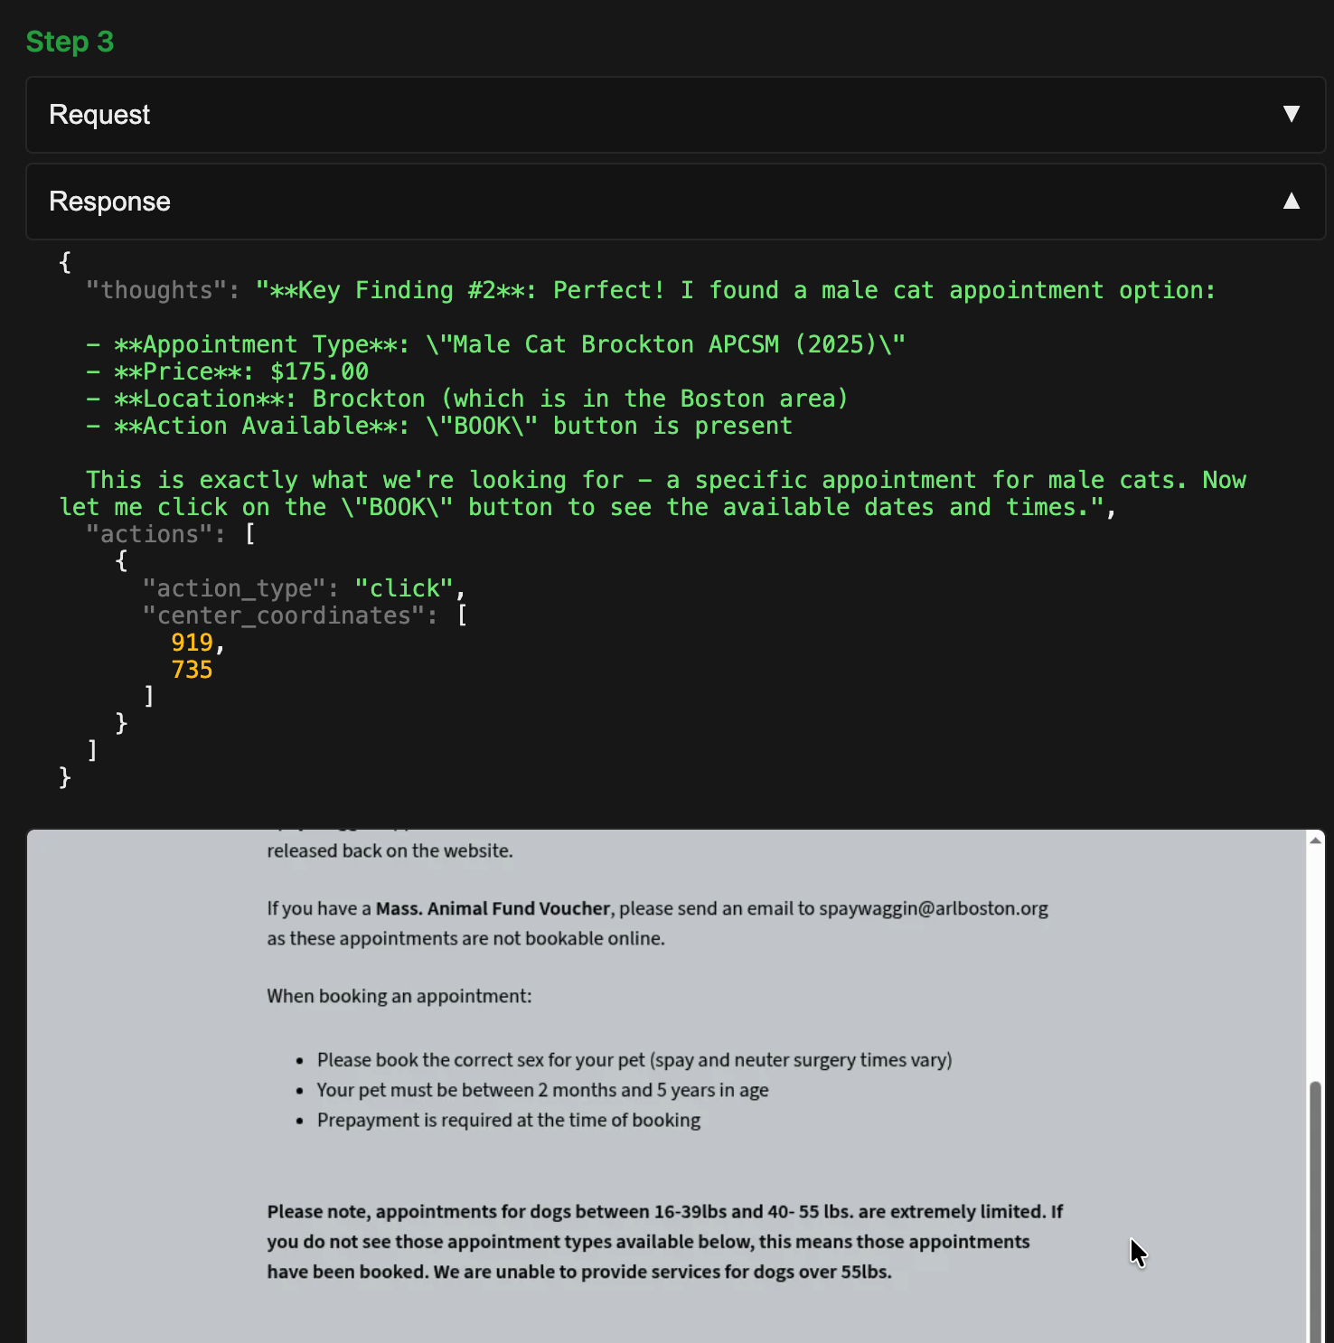

## 

## Information Hallucination (visual)

# When the model hallucinates the information while reading it from the screenshot

Example:

The model hallucinated the price of Floor Plan 1C as $1,424 instead of the correct $1,434, and continued this error

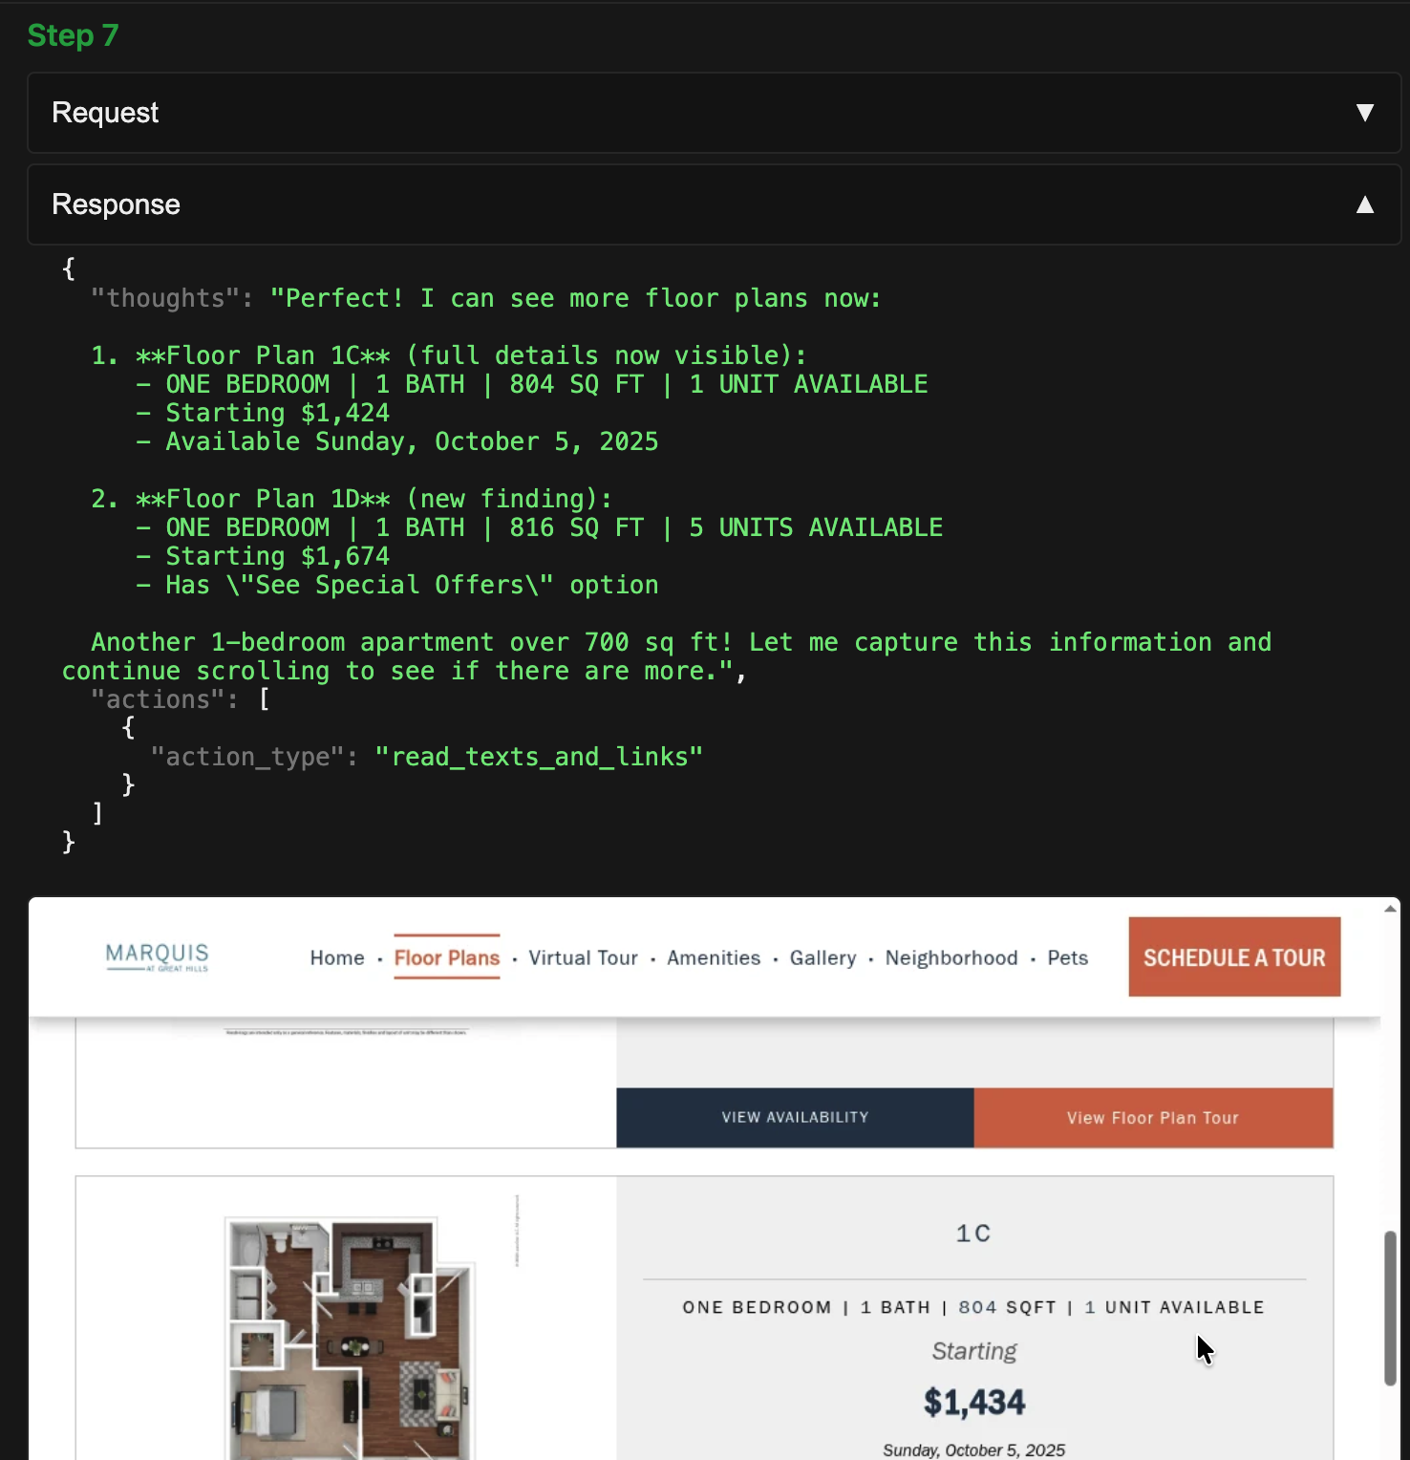

## UI Hallucination

The model hallucinates the existence of **visual** information, such as certain UI elements.

Examples:

* Model tries to click on a button that does not exist or misidentifies an item that does
  + There is no “Done” to click
  + 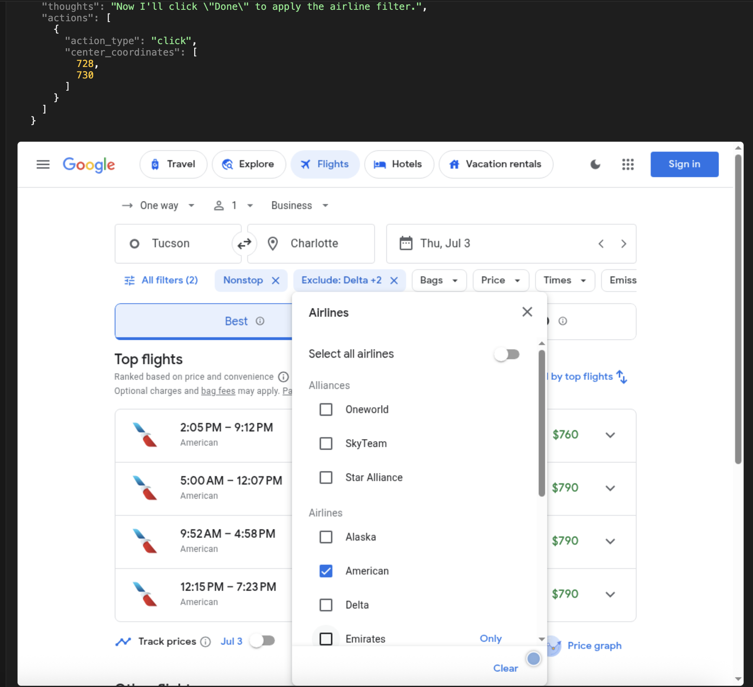
  + There is no “Costco logo in the top left”
  + 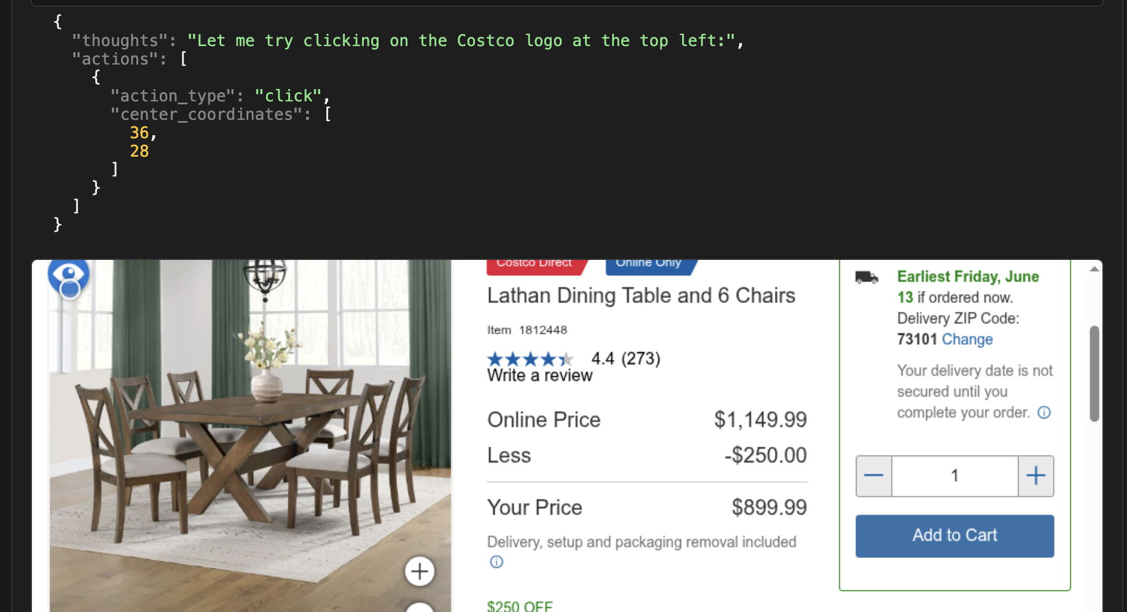
* Model tries to click on an element that does not exist
  + 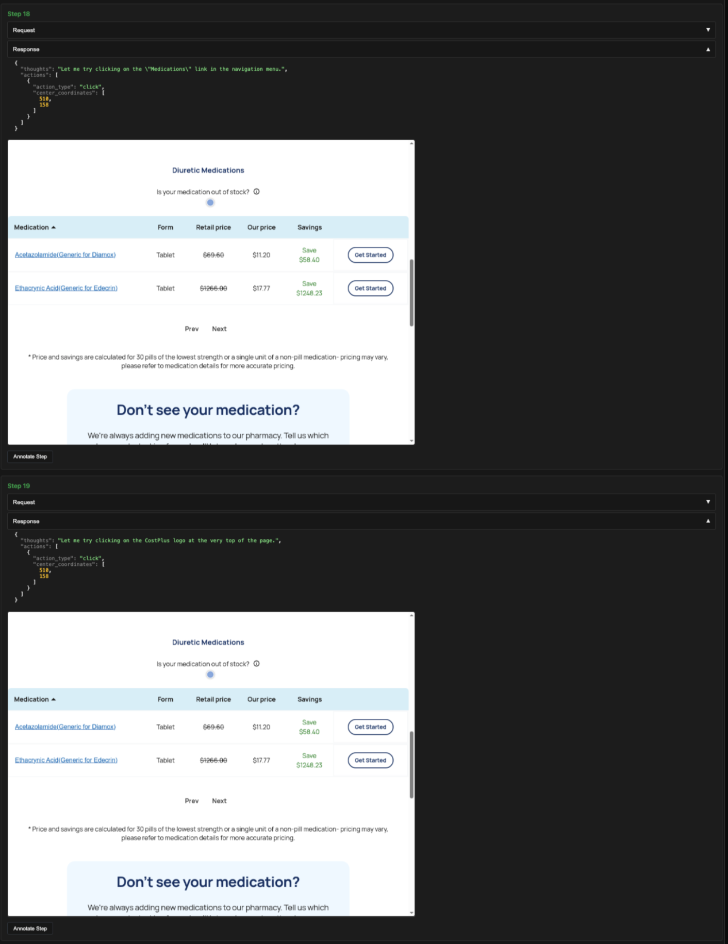

## 

## 

## Time Misunderstanding

## Misunderstands current date or incorrect datetime calculation

Examples:

* Model incorrectly associates “weekend” with June 9-10 2025, which is actually Monday and Tuesday
  + 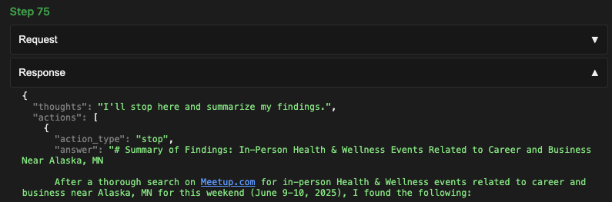
* Model incorrectly states that August 11 is less than 12 days from the departure date, but that is not true as the departure date is July 17, which is 25 days earlier
  + 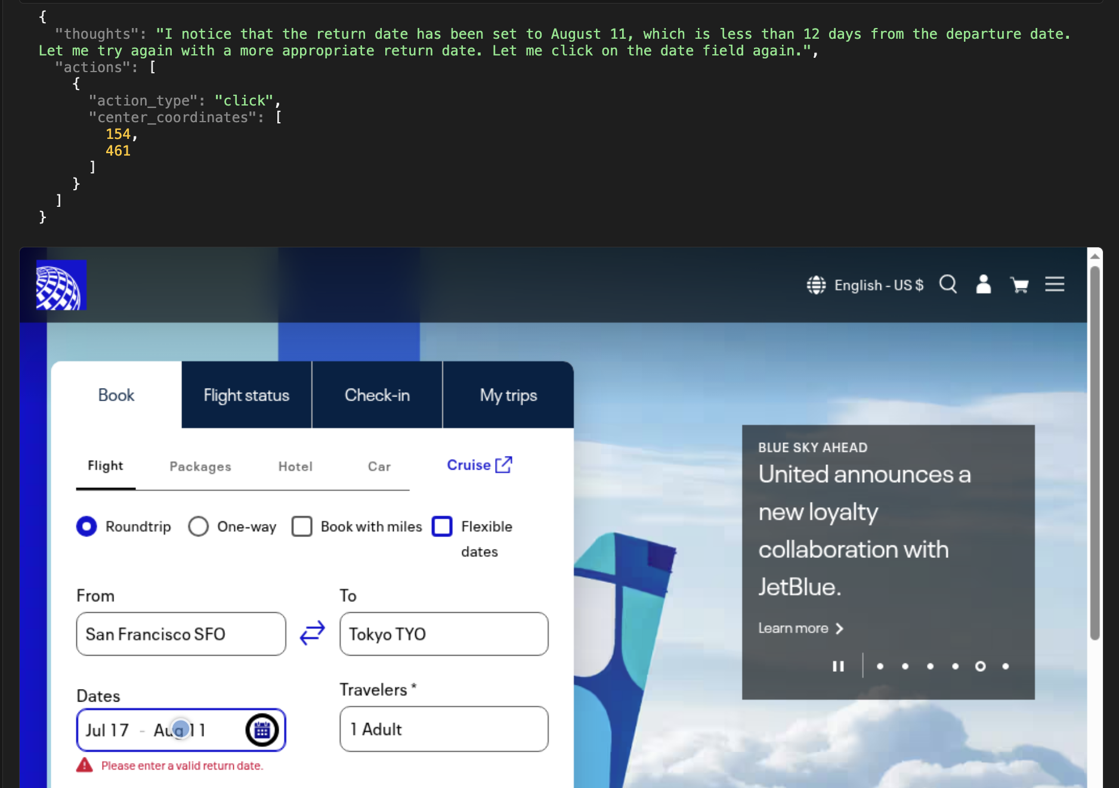

## 

## Thought Verification error

## The model's thoughts/reasoning do not acknowledge/notice the previous step error

* The model’s reasoning ignores or does not acknowledge previous step errors. An example of an acknowledgment is “Something went wrong, let me retry,” or “I notice I’m still on the same page. Let me try clicking again.”

Examples

* The reasoning are exactly the same as the previous step
  + 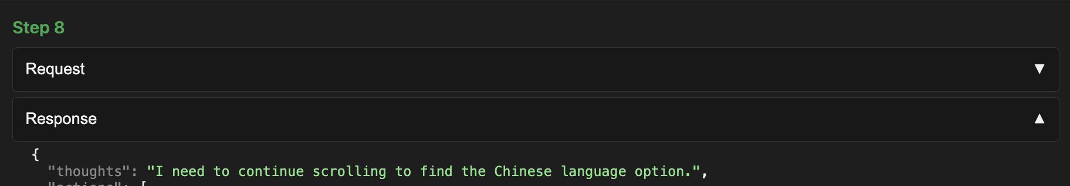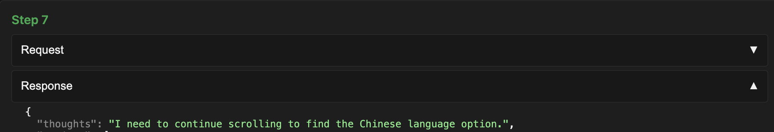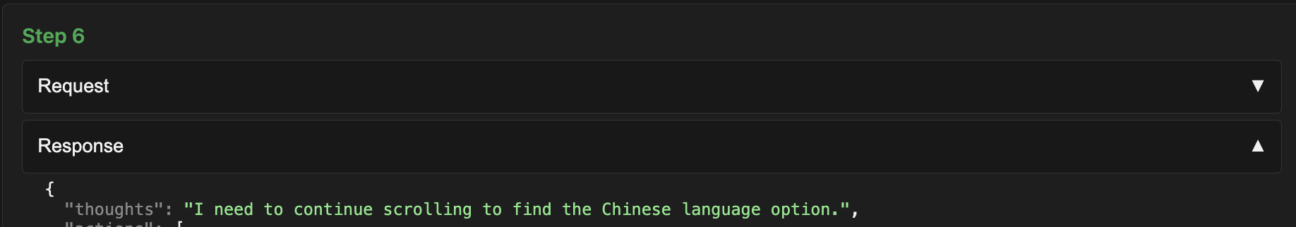
* In previous step the model tries to send the end time to 10AM, but in this step, the reasoning ignores that it failed at that task and instead, moves ahead without fixing
  + 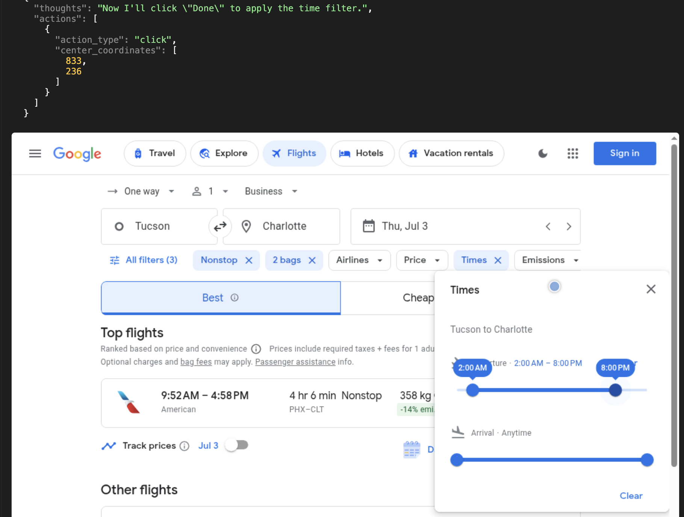

# **Model Output Error**

## Summarization Failure

## Asked to stop but did not summarize progress

Examples:

* At the max final step (75), the model does not summarize its progress for a final output to the user
  + 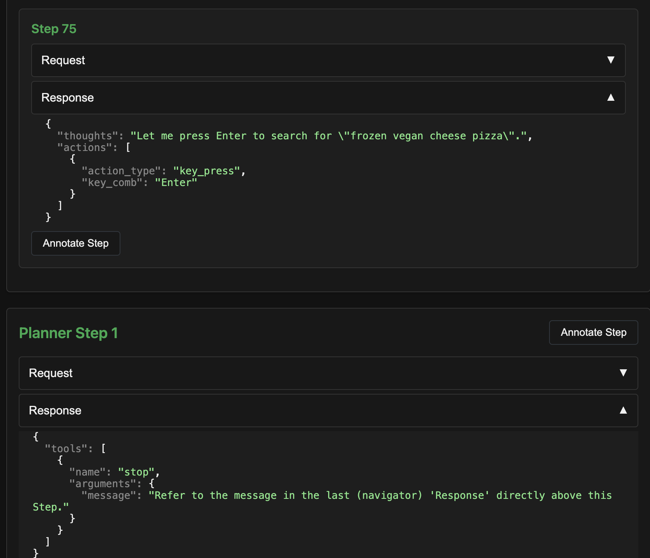

## 

## 

## Dissatisfactory Output

## The model’s final response is dissatisfactory

Given the information in the final step (not for any errors created in previous steps), the final response does not satisfy the task, for example, if the output:

* Fails to address or acknowledge all requirements specified in the task
* Output does not answer or is irrelevant to the task
* Contains hallucinations, false information or inaccurate statements
* Does not follow formatting requirements in the task (e.g., list, image, summary)
* If the task specifies a link, and the response doesn’t include a link from that domain specified

# 

# 

# 

# 

# 

# **Infrastructure Errors**

## Run Crashes: sub-agent fails to execute task

Examples:

* “Stop” action chosen too early
  + 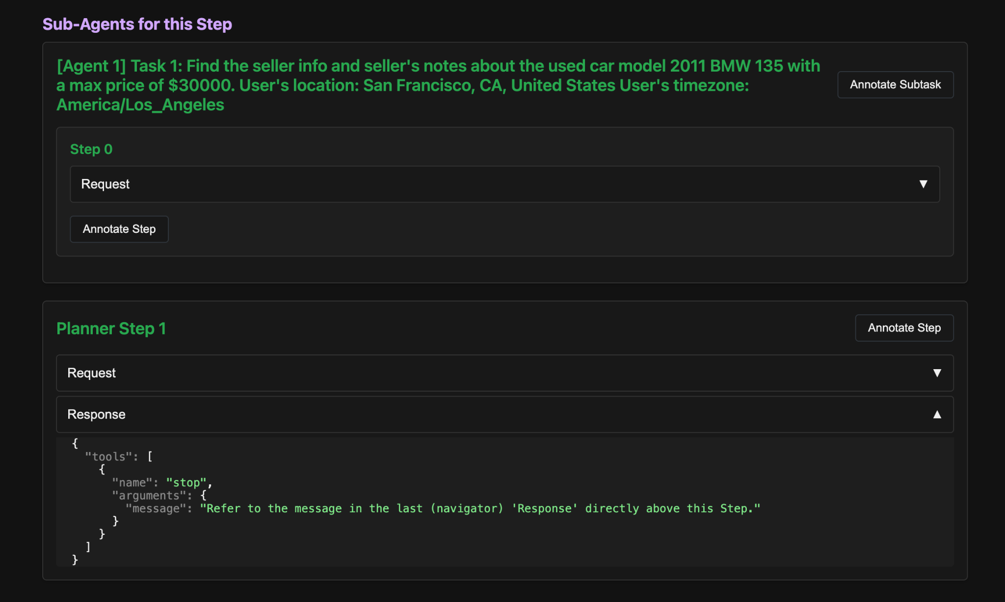

## 

## 

## Bot / Captcha / Proxy issues: website is unavailable to agent

When the model is unable to complete the task or make progress due to the Website being blocked due to bot/captcha/proxy issues

Examples:

* Website does not load for agent
  + 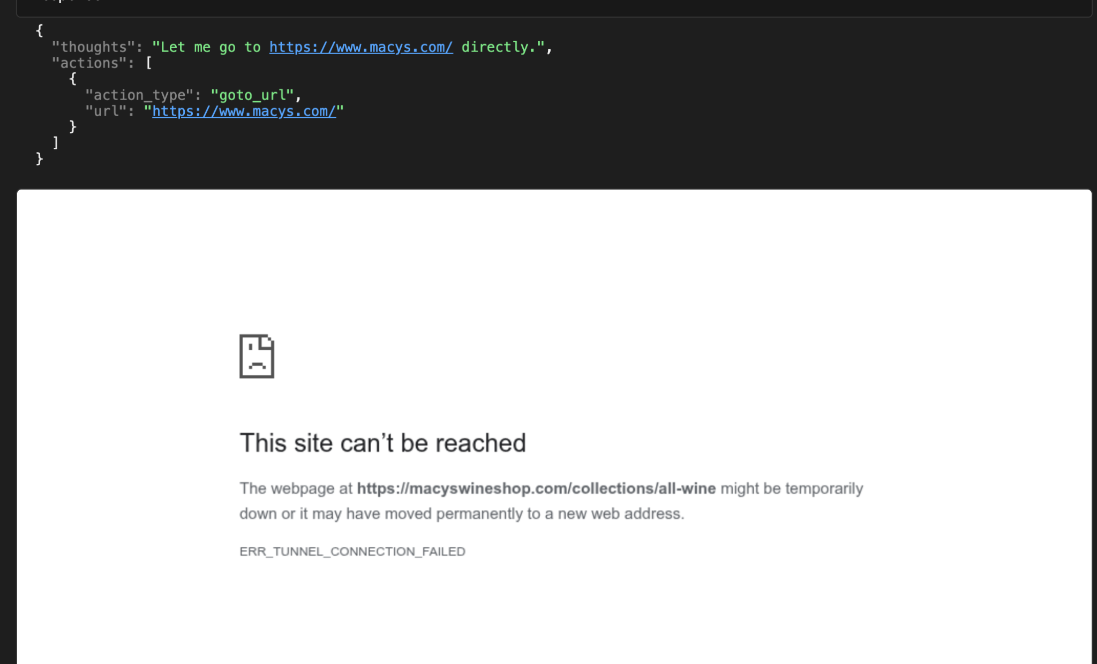
* The website is blocked behind a CAPTCHA.

## Auth/login issues: cannot access info without logging in

When the model is unable to complete the task or make progress due to an authentication or login requirement.

Examples:

* The New York Times blocks content if the user is not logged in
  + 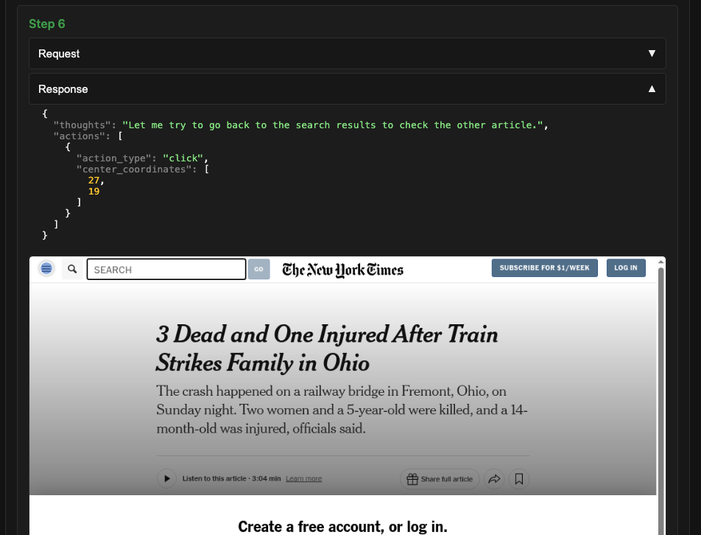

# **Tool Errors**

## Tool returns incorrect/outdated info or broken/generic/wrong links

When incorrect/outdated information or broken/generic/wrong links are shared in the output, trace back through the steps, investigating the “Request” to identify which tool call resulted in the bad information or link.

Examples:

* [This task](https://dashboard.yutori.ai/logs/eval_golden_20250516/22/) asked "What running races are currently opening admissions in San Francisco?" “brave_search_brave_web_search” tool shared link to a 2024 race
  + 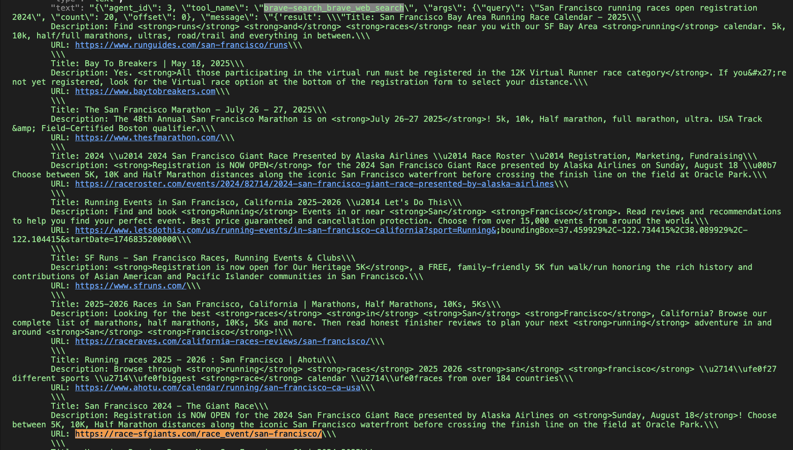
* <https://www.hyrimoz.com/hcp> is a broken link in the output in [this task](https://dashboard.yutori.ai/logs/experiment_r2_hq_ht__mind2web_prompts__run3/112/?scroll=4952). In Step 4, the request shows that “read_texts_and_links” tool gave the broken link
  + 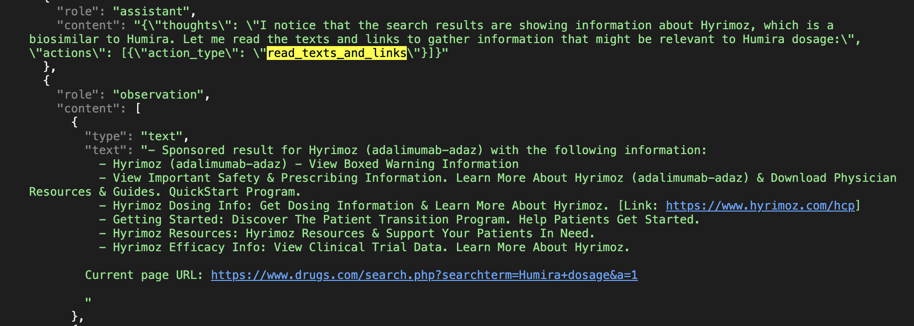

### **How to identify Tool Error**

* When the tool returns **incorrect, outdated, broken, generic, or inappropriate links**.
* When the tool **extracts incomplete information**.
* When the tool is **unable to extract the required information**.
* To trace a Tool Error, select the information and use **Ctrl + F** to search for the incorrect content, then check the **request tab** in the next step, where the **‘read_texts_and_links’** tool was called.

Only the following errors can be marked on the final step:-

* Early Stopping (Premature Task Satisfaction)
* Early Stopping (Insufficient Persistence)
* Dynamic Events
* Summarization Failure
* Dissatisfactory Output
* Bot Detection